1. Write an applet program to create calculator with minimum of six operations.
2. Write an applet program to move the ball from left to right and up and down.
3. Write an applet program to create a window as shown in the following figure

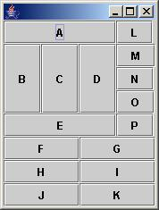

1. Write an applet program to change the foreground and background color for the text as well as text area.
2. Write an applet program in java to move ball in response to up/down/left/right buttons, as well as the 4 arrow keys, as shown.

